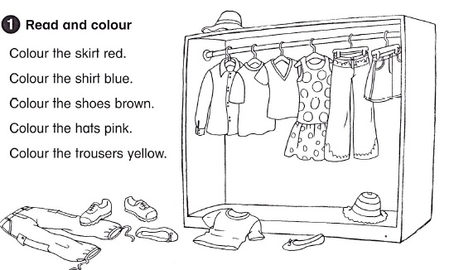

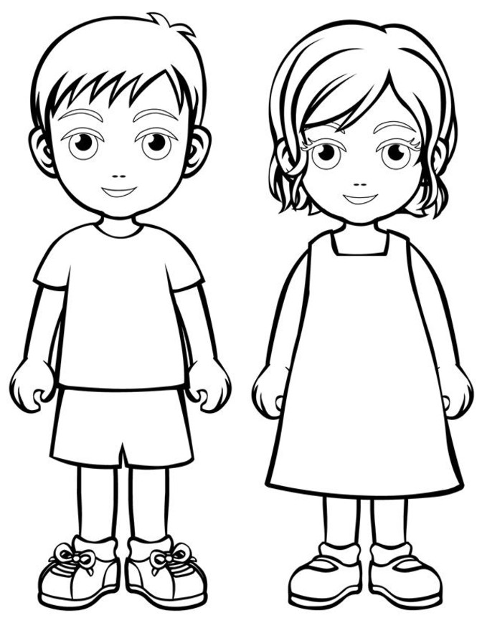

BOY GIRL

I have blue t-shirt, I have yellow dress,
purple shorts, orange socks,
brown socks, red shoes.
black shoes.

